Matrix™ Set Up for All Users Agent Info & Pictures

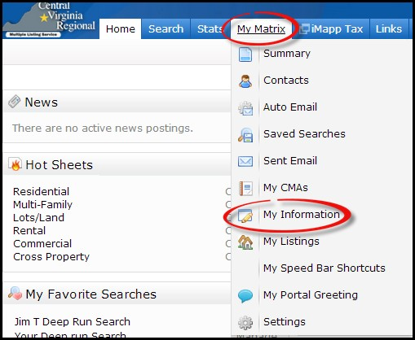
When you first log into Matrix it is a good idea to check your profile and upload your picture.

- From the My Matrix Tab choose My Information

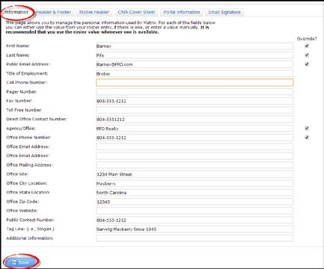
- From the My Information option, enter and verify all of your contact information and then click Save.

- You can upload your picture from several areas under the My Information option including:
- Header & Footer
- Mobile Header
- CMA Coversheet

1
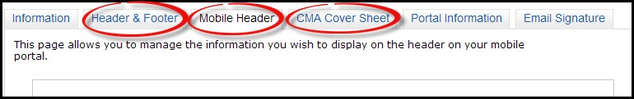

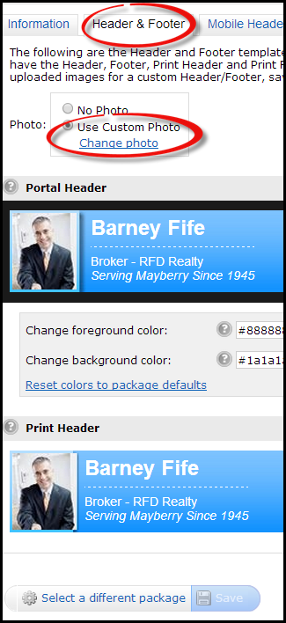
- From the Header & Footer option choose Use Custom Photo and click on the link Change photo.

- Click on the Browse button and upload your photo from your computer.

- Crop, then save.

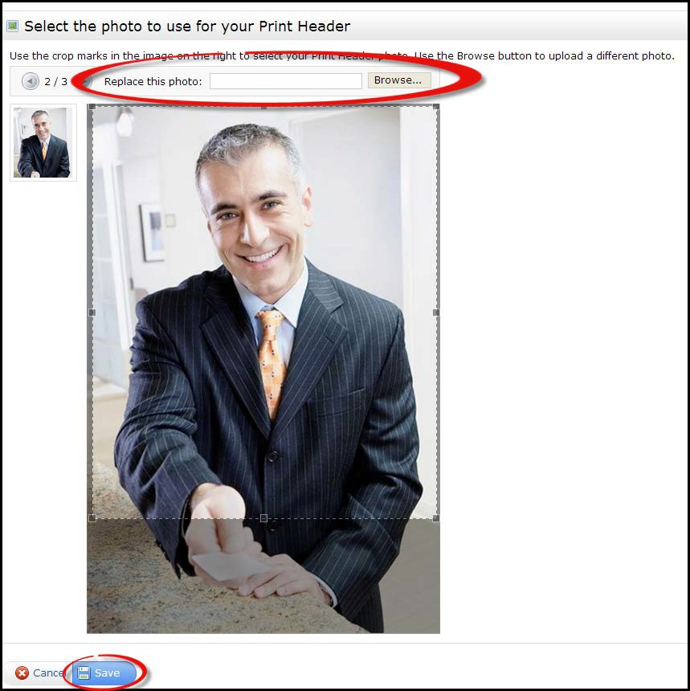

- You can upload your picture from the Mobile Header option.

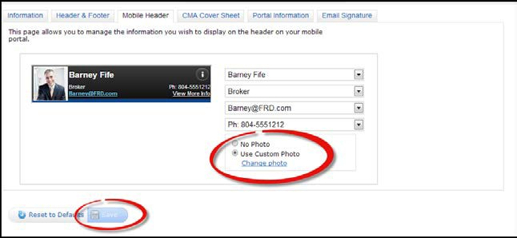

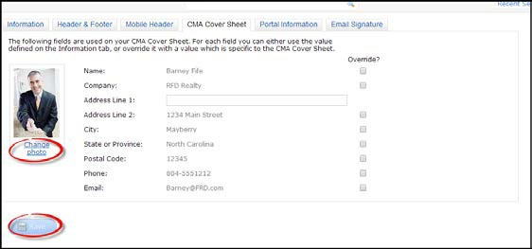
- You can upload your picture from the CMA Coversheet Option

  - You can have up to 3 different pictures in Matrix for use on your Client Portals, Mobile Header, and Headers/Footers.

